FLASH Documentation
  - Version 1.10.1 (February 10, 2026)
Daniel Terry and Manuel Juette
Single-molecule Imaging Center (SMC)
St Jude Children’s Research Hospital
Table of Contents
Introduction 2
Recommended Hardware 2
Supported Hardware 3
Hardware Setup Guide 4
Installation (stand-alone executable version) 5
Configuration 6
Using FLASH 9
Main Window 9
Advanced Tab 11
Show Live 12
Stream Acquisition 12
Movie File Format 13
Troubleshooting 13
Limitations 17
Known Issues 17

WARNING: by installing this software, the user assumes all risks and liability for any potential injury. The software is intended to be utilized by experienced professional academic scientists in accordance with all applicable laser safety and other safety procedures to minimize the potential risk of harm to users by high-power light sources. The software does not provide any safety measures, which must be implemented separately and fully validated by the user prior to operation.

Introduction
This software is intended for the acquisition of image stacks (movies) for single molecule imaging experiments utilizing total internal reflection fluorescence (TIRF) microscopes and wide-field sCMOS cameras. It is designed to be used with the SPARTAN data analysis software.
Please cite the following paper if you use FLASH in your laboratory:
Juette MF, Terry DS, Wasserman MR, Altman RB, Zhou Z, Zhao H, Blanchard SC. Single-molecule imaging of non-equilibrium molecular ensembles on the millisecond timescale. Nature Methods. 2016 Apr;13(4):341-4. doi: 10.1038/nmeth.3769. Epub 2016 Feb 15.
This software is intended only for research use in an academic setting. For licensing information, please see “license.txt” file associated with the software.
For a list of recent changes with this version, please see “release.txt” file associated with the software.
If you have comments, concerns, bug reports, or feature requests, please contact Scott Blanchard (scott.blanchard@stjude.org) or visit our GitHub page.

Recommended Hardware
- Up to four Hamamatsu Fusion cameras (C14440-20UP). For optimal results, these should have sequential serial numbers and the same firmware version.
https://www.hamamatsu.com/eu/en/product/cameras/cmos-cameras/C14440-20UP.html
- Each camera is dedicated to a specific fluorophore’s spectra band using an optical splitter such as Cairn MultiCam with appropriate dichroics and band-pass filters. The system should be adjusted so the camera fields of view are closely aligned and parfocal.
https://www.cairn-research.co.uk/product/multicam/
- Nikon Eclipse Ti2-E microscope stand configured with standard motorized filter turret, motorized encoder stage, and motorized Z-drive objective mount.
- Four Uniblitz LS6 shutters (for 473, 532, 640, 721 nm laser lines) with VCM-D4 driver:
https://www.uniblitz.com/products/ls6/
https://www.uniblitz.com/products/vmm-d4-shutter-driver/
- Optional: Thorlabs PRM1Z8 for rapid laser power attenuation with a rotating polarizer.
https://www.thorlabs.com/thorproduct.cfm?partnumber=PRM1Z8
- Arduino Due (see below) for triggering shutters, cameras, and fluidics.
- Dell Precision 7920 or similar Xeon processor (8 or more physical cores), 128 GB RAM, and Intel Optane 905P PCIe SSD (1.5 TB). If another SSD is used, make sure it has a measured sustained write speed of at least 2 gigabytes/s.
- Windows 10 and 11.

Supported Hardware
The devices listed here have been tested. More devices using the same drivers will likely also function correctly, but this has not been verified.
- Cameras:
  - Hamamatsu sCMOS: Flash 4.0 v2 (C11440-22CU), Flash 4.0 v3 (C13440-20CU), Fusion (C14440-20UP), Fusion-BT (C15440-20UP), and Quest (C15550-20UP).
  - Photometrics: Kinetix (01-KINETIX-M-C)
- Microscope stand
  - Nikon Eclipse Ti2-E
- Stage controller
  - Nikon Eclipse Ti2 motorized encoder stage (TI2‑S‑SE‑E)
  - Newport ESP300/301/302 (tested with LTA-HS motors). Must be connected by USB.
  - ASI controllers (tested with MS-2000 stage)
Must be connected by serial port (RS232) with 9600 baud rate.
  - Ludl MAC5000 or MAC6000 controller (tested with BioPrecision2 stage).
Must be connected by serial port (RS232) with 9600 baud rate.
- DAQ (for triggering shutters and cameras)
  - Arduino Due programmed with the Microsync firmware.
  - Arduino MEGA 2560 programmed with the firmware provided in a legacy project.
  - National Instruments USB-6501. We recommend against this option because the timing jitter is significantly worse than using an external device.
- Laser power control
  - LaserQuantum: Opus, Ventus, and Gem (RS232 interface).
  - Coherent: HOPS (Genesis line) and OBIS series. Only one such laser may be connected.
  - Thorlabs: PRM1Z8 motorized rotation stage (for laser power attenuation). Only one such device may be connected.
  - Cobolt: experimental support (untested).
- Power meter
  - Newport 1919-R (RS232 connection)
  - Thorlabs PM16-121 (others probably work but have not been tested)
- Autosampler
  - SIELC Alltesta (7/6 valve, 120 uL syringe, 96-well plate)

Hardware Setup Guide
For a general overview of the experimental setup, please see the following paper:
https://www.nature.com/articles/nmeth.3769

Cameras:
- All cameras being used together should have the same camera model and firmware version.
- Cameras should be oriented so that the image matches the field of view of the eyepieces, with only horizontal flipping required. On many sCMOS camera modes, vertical flipping may interfere with line-by-line synchronization.
- USB-connected cameras generally should each have a dedicated interface card.
- Follow all manufacturer recommendations for camera hardware installation, such as appropriate device drivers, software configuration, and BIOS settings.

Triggering:
- Configure the shutter driver(s) so that the shutters are closed with 0V input and open with +5V input. With Uniblitz drivers, connect the appropriate DAQ outputs to the “pulse input” port.
- The camera trigger DAQ line should be connected in parallel to the “external trigger” input of all cameras.
- For Arduino MEGA (legacy) DAQ, pins A0-A3 control the four shutter lines (e.g., 473, 532, 640, 721 nm), pin 13 is used for camera triggering, and pin 2 is used for fluidics triggering.
- For Microsync device (Arduino Due), pins D8-11 control the four shutter lines (e.g., 473, 532, 640, 721 nm), pin D7 is used for camera triggering, and pin D6 is used for fluidics triggering. Optionally, pins D12 (input) and D13 (output) are used for an interlock loop. We recommend using the custom shield for this device to convert internal 3.3V to TTL (5V) expected by most devices.

Other:
- Recommended: disable power management in Device Manager for all USB devices (and any hubs they depend on). Otherwise, devices may randomly fail when put to sleep. This is a known problem for Hamamatsu cameras connected via USB PCIe cards.
- Control software associated with each device, such as the RemoteApp program for LaserQuantum lasers or Coherent Connection can be useful both to verify the device is properly connected and determine the COM port and other connection parameters for it.

Installation (stand-alone executable version)
The stand-alone executable version is recommended for all users unless you plan to customize the code to add new devices. Before installing, please install the following pre-requisites, according to the specific hardware actually installed. No license should be required to download any of the software.
- 64-bit LabVIEW run-time engine 2023-SP3. Required for all hardware configurations.
https://www.ni.com/en/support/downloads/software-products/download.labview-runtime.html#484336
- MATLAB is required for live particle counting.
- DAQ-mx version 21.8 (for the USB-6501 device only):
https://www.ni.com/en-us/support/downloads/drivers/download.ni-daqmx.html#445931
- Latest version of DCAM (for Hamamatsu cameras). We have tested most extensively with versions 22.2.6391 and 22.8.6486. https://dcam-api.com/
- Latest version of PVCAM (for Photometrics cameras). We have tested most extensively with version 3.10.1. https://www.photometrics.com/support/download/pvcam
- Nikon Ti2 SDK 64-bit, which includes the device driver for the Ti2 microscope.
https://nisdk.recollective.com/microscopes
- Thorlabs Kinesis (for Thorlabs PRM1Z8).
https://www.thorlabs.com/software_pages/ViewSoftwarePage.cfm?Code=Motion_Control
- Coherent Genesis driver. Your laser should have included a CD that will install an application called “OPSL” and the driver. If you need to install the driver directly, it can be found in a directory similar to “CDM v2.12.28 WHQL Certified” on the CD.
https://www.coherent.com/support
Once these packages are installed, unzip FLASH.zip to “C:\FLASH” and create a desktop shortcut to FLASH.exe. Ensure all devices are initialized and connected. Run FLASH.exe to start the program.

Configuration
FLASH is designed to support a variety of hardware configurations, with the settings for each instrument contained within a unique file in the “Config” folder. When FLASH starts, it will prompt the user to select amongst these files to determine which devices are present and the settings to use. You can modify any existing configuration files by clicking the “Edit” button below the list box. Clicking “Save” on this dialog will overwrite the selected configuration file, while “Save As…” will create a new file. To remove a configuration, simply delete the corresponding file in the Config folder. To rename a configuration, simply rename that configuration file on disk.
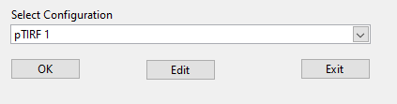 | 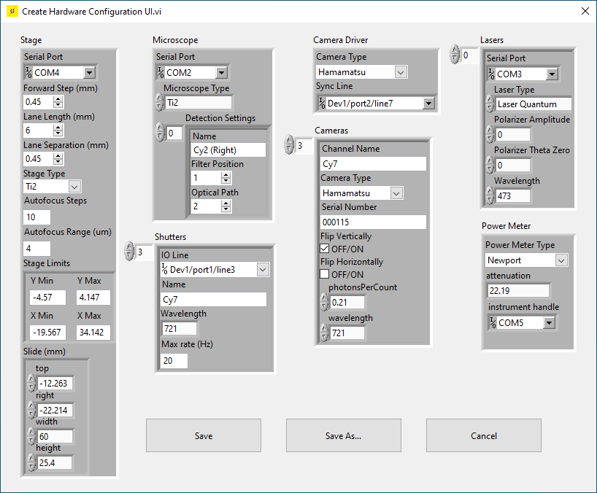
Below is a list of the configuration options:
- DAQ Configuration
  - Shutters
    - IO Line: NI DAQ port connected to the shutter driver for this laser line.
    - Name: name of the camera channel associated with this laser.
    - Wavelength: wavelength of the laser line in nanometers.
    - Max rate (Hz): defines how rapidly the shutters can cycle before overheating and/or being damaged. Refer to your device’s manual for this number.
  - Device type: type of DAQ device connected. Choose “Disabled” if none available – cameras will use internal triggering.
  - COM Port: connection port for Microsync and Arduino devices.
  - Fluidics trigger line: NI DAQ port used for triggering fluidics.
  - Camera trigger line: NI DAQ port used for triggering the cameras.
- Lasers
  - Laser Type: choose the driver type for this laser (LaserQuantum, OBIS, Coherent HOPS, PRM1Z8, or Disabled).
  - Serial Port: for RS232 connections (for LaserQuantum, OBIS, and Cobolt lasers).
  - Wavelength: wavelength in nanometers of the laser line. Must be identical to the number listed in the corresponding shutter configuration.
  - Polarizer theta zero (PRM1Z8 only): polarizer angle in degrees where light transmission is highest.
  - Polarizer amplitude (PRM1Z8 only): power in milliwatts of laser intensity reaching the sample when the polarizer is set to theta zero.
- Stage
  - Stage Type: Select the stage driver or “Disabled” if none are connected.
  - Serial Port: connection port for ESP30x, Ludl, and ASI stages.
  - Forward Step (mm): sets how far the stage moves between successive movies (X direction). Controls the “Move Forward” button in the FLASH front panel. Should be adjusted so that the illumination intensity drops to zero at this distance so that the next field is not photobleached by the previous movie.
  - Lane separation (mm): controls how far the stage moves between successive lanes (Y direction).
  - Lane Length (mm): controls the usable area of the channel in the “forward step” direction. Adjust this to control the default photobleaching length.
  - Autofocus steps: number of frames (Z positions) to acquire for software autofocus (default 10).
  - Autofocus range (um): full range used for software autofocus. The steps size is range/(steps-1). Default is 4 µm.
  - Stage limits: defines software stage limits shown as a dotted line in the plate diagram in the Main Window. Set to -/+Inf to disable.
  - Slide (mm): slide dimensions used to translate stage X/Y coordinates to the slide image in the Main Window.
- Microscope
  - Microscope Type: Set to “Disable” if no supported stand is installed.
  - Serial port: unused.
  - Detection settings: this array populates the “Detection” dropdown list in the Main Window and defines the position of the filter block and light path inside the microscope. For the Ti2 microscope, the light path values are as follows: (1) Eyepieces, (2) Right port, (3) Bottom/U port, (4) Left port.
- Camera Driver
  - Camera Type: select the camera driver to use (Andor, Hamamatsu, or Photometrics).
- Cameras
  - Channel Name: short string used to uniquely identify each camera. This should be one of the following: Cy2, Cy3, Cy5, Cy7. This field is not intended to specify the fluorophore or sample, but instead is the name of the spectral channel. This is used both in the user interface to identify each camera and in the metadata for automating analysis.
  - Serial Number: see camera documentation and stickers on the camera. This is typically a six-digit number that uniquely identifies the camera.
  - Flip Vertically: if true, raw images from this camera are flipped vertically so that it matches the orientation of the other cameras. If possible, arrange your optical system to avoid using any “flip” settings. Also please be aware that flipping vertically with sCMOS cameras may result in slight asynchrony between channels due to the line-by-line readout process; this will not be a problem in ALEX or stroboscopic modes and should not be an issue at all with Flash cameras.
  - Flip Horizontally: if true, raw camera images from this camera will be flipped horizontally for display and saving to file so that it matches the orientation of the other cameras.
  - photonsPerCount: photoelectrons per ADU (arbitrary camera readout units) conversion factor, as specified in the data sheet from the camera manufacturer. There is one entry in the array per camera readout mode. This is only used for metadata to assist in automating downstream analysis (e.g., in SPARTAN). This field can be left empty for Hamamatsu cameras because the conversion factors can be read from the camera.
  - Wavelength: wavelength in nanometers of the laser that is used to directly excite fluorophores in this spectral band. For integration with SPARTAN, it is important that this value matches the shutter/laser wavelength configured above.
- Power meter
  - Power meter type: driver for the power meter or “Disabled” if none connected.
  - Instrument handle: COM port for RS232-connected devices (Newport).
  - Attenuation: power sensor reading is multiplied by this number to match the actual power reaching the sample.
- Autosampler
  - Device Type: select the connected device, Simulated for testing, or Disabled if not used.
  - Serial port: COM port for connecting to the device
  - Valve Position Names: plain text names of each valve position (e.g., “1. Needle port”), used only for display in the Main Window.
The camera list can have any number of entries associated with all cameras in a laboratory or just a subset for each instrument. The lists for all other devices should include those actually connected to the instrument.
The default configuration file can be specified by editing the Init.xml file. Change the “Hardware Configuration File” value to the name of the configuration file you want to be the default. This file can also be modified so that the default corresponds to the hostname of the computer FLASH is run on. This is useful when running the software on many instruments within a facility.

Using FLASH

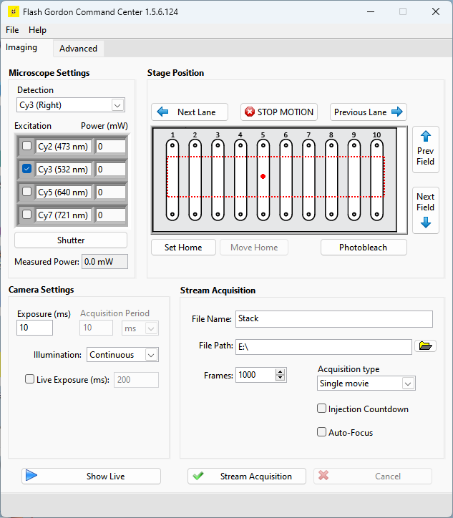
Main Window
Turn on all devices, wait for them to finish their startup routine, and launch FlashGordon.exe (or FLASH.vi for source code version). Select the appropriate configuration (see above) and click “Ok”. After starting, the Main Window will open. The Main Window is used for controlling all devices and collecting data:
Microscope Settings
- Detection: specifies the microscope light path, including the filter set and imaging port.
- Excitation: the check boxes specify which laser line is active (will open in Stream Acquisition and Show Live modes, or when manually clicking the “Shutter” button).
- Power (mW): change this value and hit Enter to adjust the laser power for this line (if configured). If the power on the device is independently adjusted, the Main Window will not be automatically updated.
- Shutter: pressing this button will open/close the currently active shutter(s).
- Measured Power: if a power meter is connected and configured, this will show the current laser power (measured power times attenuation factor).
Camera Settings
- Exposure (ms): time that the camera is exposing and the laser shutters are open within each frame interval. In continuous illumination, this is the same as frame interval.
- Acquisition Period: time period between the start of each frame.
- Illumination: select the imaging mode (Continuous, ALEX, or Stroboscopic). See the section below for a more complete description of these options.
- Live Exposure (ms): if checked, “Show Live” will use this exposure time instead – the “Exposure (ms)” field is always used for “Stream Acquisition”. This can be useful for manually focusing at low before taking each new movie.
- Show Live: opens the Live Viewer and opens any active shutter(s). Click again to close the viewer.
Stage Position:
The image in the center of this pane is a diagram of the slide. This image can be changed by replacing the file “slide diagram.png” in the FLASH root folder. The red dotted lines show the software stage limits. The large red circle shows the current stage position.
- Next/Prev. Field: moves the stage in the X direction (in line with fluidics ports) by the interval specified in the configuration file. This interval is also used clicking the “Stream Acquisition” button with “Auto-advance” checked.
- Next/Prev. Lane: moves the stage in the Y direction (towards another channel) by the interval specified in the configuration file.
- Photobleach: move the stage in the X direction in small increments for the full distance specified in the configuration file. The purpose of this mode is for the user to photobleach any unwanted molecules on the surface in the current lane. If configured, laser power will automatically be increased before motion starts.
- Set (home): use the current stage position as “home”. With the ESP301, this sets the zero position on the stage controller itself. With Ti2, this only sets a software zero position since the Ti2 does not have a configurable “home” position. Zeroing the position on the Ti2 control pad has no effect on this setting.
- Return to home: move stage to the zero position (if set). Use care when setting the zero position to avoid damage to the stage and objective.
- STOP MOTION: abort any current stage motion (such as photobleaching command).
Stream Acquisition:
- File Name and Path: any file extension is ignored (.tif will be appended to the name regardless). Any folders must first be created by the user.
- Frames: number of frames to acquire in a stream acquisition (not including skipped frames specified in the Advanced tab).
- Acquisition Type:
  - Single movie: acquire one movie in current field of view.
  - Movie series: acquire several movies, moving to a new field after each, with files numbered like this: “…_001.tif”, etc. All movies are within one lane.
  - Multi-lane series: acquire several movies, moving first across fields (Y direction) and then across lanes (X direction), with files numbered like this: “…_A01.tif”. Letters represent fields (X) and numbers are lanes (Y).
  - Sweep Parameter: acquires several movies varying the selected parameter(s), such as laser power, through a specified series of values. Files are numbered according to the selected parameter(s), e.g., “…_100mW_000.tif”.
- Injection Countdown: at the start of each stream acquisition, a timer appears that counts down to zero to mark the moment shutters open and the first frame is exposing. This mode is useful for timing manual injections with the start of acquisition.
- Auto focus: enables image-based autofocus. At the start of each movie, the laser power is reduced to minimum (if configured), a Z stack is acquired to determine the optimal Z position, and the laser power is returned to the previous value before starting the acquisition. This can add a significant delay, please be patient.
- Stream Acquisition: start acquiring movie(s).
- Cancel: stops the acquisition early. You will be prompted to save the truncated movie if desired.

Advanced Tab
Settings and commands that are less commonly used, a few of which are described below:
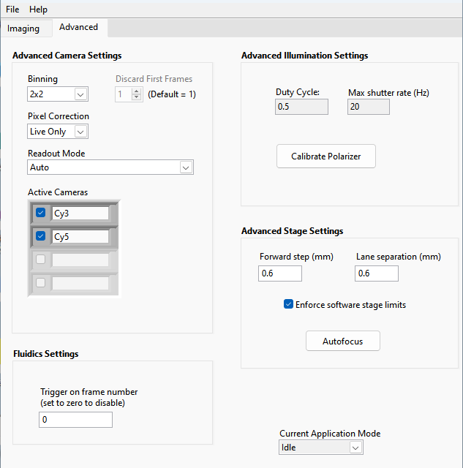
- Binning: on-camera pixel binning. Default is 2x2.
- Readout Mode: if ‘auto’ is elected (default), automatically selects the readout mode that gives the maximum field of view size and lowest noise levels for the parameters selected by the user. This value should be changed in some scenarios, such as when one readout mode has other desirable properties like a larger full-well depth or when the user wants to maintain consistency in camera settings between recordings with different exposure times.
- Active Cameras: select a subset of connected cameras to be used in Live and Stream Acquisition modes.
- Fluidics trigger: at this frame number, a one-frame TTL pulse will be sent to trigger an external device. Set to zero to disable.
- Calibrate Polarizer: initiates a series of polarizer motor movements and power meter measurements to determine the calibration parameters to translate power settings to polarizer angles. These values must be manually entered into the configuration file; it is not automatically updated.
- Forward step/lane separation: manually adjust the stage movement distances. These values are only kept during the current session. You must edit the configuration file to make any changes permanent.
- Enforce software stage limits: if unchecked the stage limits in the configuration file (red dotted line in the main tab) are ignored.
- Autofocus: manually start the autofocus routine in current field of view, without changing laser power.

Autosampler Tab
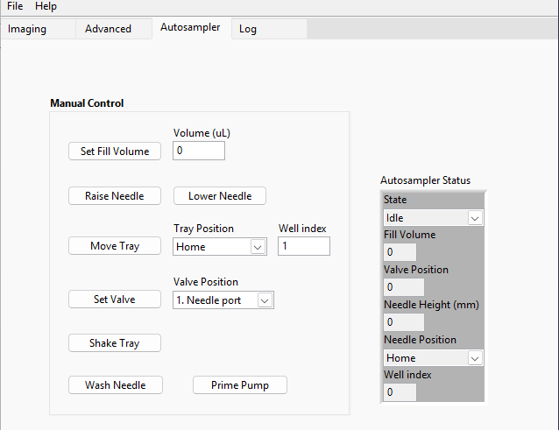
This tab will be visible only if an autosampler is configured and connected.
- Manual control: buttons directly execute basic movements on the device. The parameter fields are not updated as the device moves.
- Autosampler Status: displays the current positions of the various components of the device, including valve positions and needle arm position.

Show Live
To see acquired images from the cameras without saving any data, click the “Show Live” button in the main window. A new window will appear showing the frame data from all active cameras. The Live Viewer window includes several controls at the top. These settings only affect the display of the pixel data and have no effect on the acquired movies.
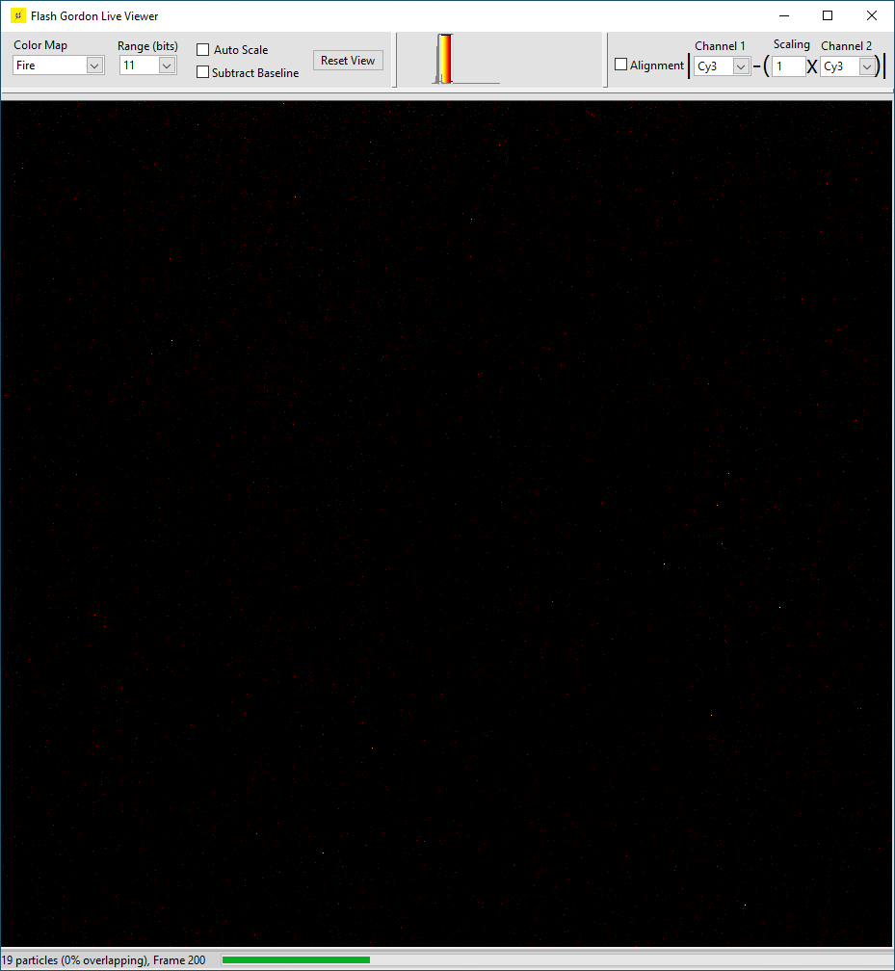
- Color Map: changes the mapping of monochrome pixel intensity values to colors.
- Range (bits): specifies the maximum pixel value of the histogram.
- Auto Scale: if checked, the histogram scale bar will be automatically adjusted to be in an optimal range. Uncheck to manually set the position of the scale bar.
- Subtract Baseline: subtract the bias level from each camera in order to ensure all cameras have the same baseline.
- Histogram: gray bar chart shows the pixel intensities of the acquired images from all cameras. The colorful plot shows how these values are translated to colors in the viewer. The ends of this plot can be moved to adjust the minimum and maximum values the mapping of pixel values onto the color scale (if “Auto Scale” is not selected). Typically the lower end is set on the large peak corresponding to background pixels, while the upper end is set so that the molecule pixel intensities are clearly visible but not oversaturated, especially when adjusting the focus.
- Alignment: if checked, the Live Viewer will display the image of one camera subtracted from another to adjust their relative alignment. The scaling parameter is useful when two spectral bands have very different intensities and is most often used with the far-red (Cy7) channel.
- Status Bar: displays the number of frames recorded, a progress bar for the recording, and an estimated number of detected particles in the first channel (using an algorithm similar to the one used in SPARTAN).
NOTE: the Live Viewer executes in a separate thread that only updates every ~100 ms. Images may update slowly or cameras may appear out of sync. This is all normal. To verify that devices are properly synchronized, use an oscilloscope connected to the outport ports of the cameras and other devices.

Stream Acquisition
To acquire a movie, click the “Stream Acquisition” button. The Live Viewer window will appear and the cameras will stream raw data to disk. A progress bar will appear in the bottom of the viewer window. When the acquisition is complete, the live viewer will close. The raw data is converted into a .tif file in the background, with the progress displayed at the bottom of the main window next to “Saving Movie”. There is no problem with starting an acquisition while the previous movie is still saving. If you click “Cancel” or close the live viewer window, you will be prompted on whether to save the already-acquired frames.
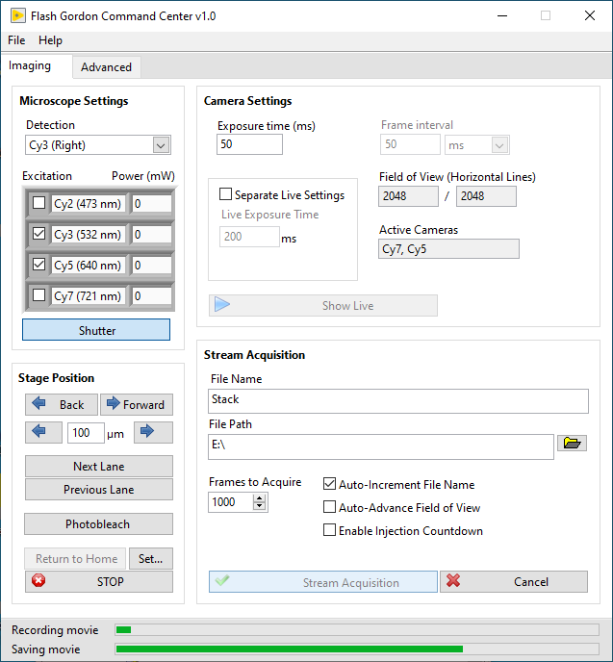

Movie File Format
Image stacks (movies) are saved as monochrome, uncompressed .tif files with the 16-bit pixel data. For each frame, the image data is flipped vertically and/or horizontally according to the configuration and the images from all active cameras are then assembled into a montage. The montage is designed to simulate the layout of an optical splitter. For 4-channel acquisitions, the panel order by wavelength is bottom-left, top-left, top-right, bottom-right (Cy2, Cy3, Cy5, Cy7, respectively). For 3-channel acquisitions, the field corresponding to the inactive camera is filled with zeros. For 2-channel acquisitions, the fields are tiled horizontally left-to-right by wavelength.
Movie files use the BigTIFF standard, which uses 64-bit offsets to enable file sizes larger than 4 GB: https://www.awaresystems.be/imaging/tiff/bigtiff.html . This is required for instruments with sCMOS cameras, which often produce movies that are 30 GB or larger. The movies have one Image File Directory (IFDs) for each frame, all of which are stored at the beginning of the file. The pixel data is saved in one contiguous block at the end of the file (offset=16384 bytes), with each frame being a single stripe without any intervening bytes. This allows the pixel data to be efficiently read from disk for data analysis.
The movies include many metadata tags, but these two are of particular importance. The pixel size parameter is set for the Flash cameras and a 60x objective and may not be correct for any other setup.
- ExposureTime (33434): interval between camera frames.
- ImageDescription (270): plain-text description of the experiment and instrument parameters, which can be used to automate the analysis process.

Troubleshooting
Synchronization
Be sure to verify synchronization of cameras before using an instrument for routine experiments. Connect the “trigger/expose out” port of each camera to an oscilloscope and verify that the rising edges are synchronized within ~1 ms. Check this at varying exposure times between 200 ms and 2 ms. With the NI DAQ and exposure times faster than 2 ms, the cameras are internally triggered and may lose synchronization over time.
How do I determine the virtual addresses of the ports on the NI DAQ?
Check the documentation for your DAQ and use the NI MAX utility. NI DAQs often include helpful stickers. If in doubt, use the NI Test Panels utility (accessible from NI Device Manager) to set the line voltages and test with an oscilloscope or volt meter.
Missing DLLs
FLASH works with a set of drivers for common microscope hardware. For licensing reasons, not all of these can be packaged together with the software and must be installed by the user. Check the installation instructions to verify all required software is installed. If the problem persists:
- Ti2_Mic_Driver.dll: install Nikon Ti2 SDK. Then copy this file from “C:\Program Files\Nikon\Ti2-SDK\bin\” into FLASH’s dll folder.
- tmcamcon.dll: install the Hamamatsu Video Capture library.
- dcampapi.dll or dcimgapi.dll: install DCAM (camera drivers).
- Thorlabs….dll: install the Thorlabs Kinesis library.
- nilvaiu.dll: install the National Instruments DAQmx software.
Error -1073807202: A Code Library Required by NI-VISA Could Not Be Located
Although it should have come with DAQmx, you may need to install the NI-VISA driver.
https://www.ni.com/en-us/support/downloads/drivers/download.ni-visa.html#306119
Failed load to configuration
Your configuration file is invalid. We recommend against manually editing these files as this is highly error prone. Use the configuration dialog in FLASH to edit these files instead.
Microscope is not detected (Nikon Ti2)
You must install the Nikon Ti2 SDK in order for the microscope to be detected. Verify the USB connection and the device shows up in Windows Device Manager.
“No cameras detected!” error on startup. (Hamamatsu cameras)
Verify the cameras are turned on and have completed their startup procedure (status lights not flashing) before starting FLASH. If no lights come on at all, check the power connection. With the Fusion camera, the red lights near the coaxial data ports never stop flashing, it suggests the camera could not establish a connection to the computer; check your USB or coaxial data connection. Finally, double check the configuration file to make sure the serial numbers exactly match. The DCAM Configurator tool can be helpful for this task.
In some cases, the cameras take a long time to initialize and FLASH times out. It’s worth trying a few times before giving up.
If you are using the compiled version but also have LabVIEW and the Hamamatsu Video Capture (HVC) library installed, there may be a conflict with the copy of tmcamcon.dll included with FLASH and the version installed in C:\Windows\System32. To resolve this problem, remove the copy of tmcamcon.dll from the FLASH directory.
If all else fails, use software provided with the camera manufacturer such as HCImage and work with the camera vendor to troubleshoot the issue.
“Invalid camera model” (Hamamatsu cameras)
Only a limited number of Hamamatsu camera models are currently supported. Please check the “Supported Hardware” section above. For the source code version, a new model number can be added to the case structure in the file “Hardware\Hamamatsu Camera\Max Lines Auto.vi”. For the stand-alone version, please contact us with the camera model number.
One of my cameras has an inverted or rotated image relative to the others
You may need to change the Configuration settings for this camera to set one of the “flip” settings to “true”. If it is rotated, this must be fixed by physically rotating the camera so that it is aligned with the others.
I get errors about the lasers
FLASH will not start if any hardware in the configuration file is not found or connecting to it failed. Either change the device type to “Disabled” or delete the Laser Configuration entry corresponding to the device.
Lasers are on and shutters are open but I see nothing in the cameras/eyepieces
First, manually select filter and output port to eyepieces on the microscope body or remote control pad and verify you get the expected signal. If this does not work, the problem may be with the instrument or sample. Otherwise, check your configuration file under Microscope Configuration – Detection Settings. Microscope Type should be “Ti2”. The integer values correspond to the filter turret position (same as written on the filter cubes themselves) and light path (output port). For the Nikon Ti2 microscope stand, the light path has the following values:
- Eyepieces
- Right port
- Bottom (U) port
- Left port
If you see all black in the camera Live Viewer, first adjust the scale bars (or use the Auto Scale mode). This should be showing a rapidly changing static signal – zoom in to verify if this isn’t clear. If the image is completely black or completely static, there may be a problem either with the cameras or with the triggering. The cameras will not acquire frame data unless they receive triggering pulses on their “Trigger Input” line from the DAQ. Check the physical connections and verify the output port specified in the configuration file under Virtual Camera – Sync Line is connected to the “external trigger” port of the camera.
When I move to a new field, some of the molecules near the border are already bleached.
Adjust the stage parameters in the configuration file to take a larger step in that direction. These values will depend on the size of the illuminated area.
I get errors about dropped frames.
Frame data may not get saved to disk if the disk is not fast enough for the large volume of data produced by sCMOS camera arrays. The simplest solution is to get an SSD drive dedicated to saving movies with a sustained write speed > 2GB/s. Second, limit the use of other disk or CPU-intensive applications (such as Python or MATLAB for data analysis) while recording a movie. Finally, before acquiring a movie, wait until the previous one has completely saved to disk.
FLASH is in a strange state where buttons do not work or behave unexpectedly.
Stand-alone version: close FLASH. Verify the icon in the taskbar shows that it successfully exited. If it does not, use Task Manager to kill the process. Turn off the cameras, wait 10 seconds, and turn them on again. Wait for the cameras to complete their startup procedure and start FLASH. If this does not solve the problem, restart your computer.
Still need help?
Please email scott.blanchard@stjude.org with the following information:
- Name, institution, principal investigator.
- Version of FLASH and type of installation (stand-alone or source code).
- Describe the problem in detail. Take a screenshot of any error dialogs.
- If applicable, attach the relevant log file (C:\temp\FLASH.log).
- Is the problem reproducible? If so, what are the steps to reproduce it?
- If using the source code, have there been any modifications? If so, have you tried using the original version?
- Describe your instrument in detail:
  - Camera make, model, and connection interface (e.g., USB). Are you using dedicated PCIe cards for each camera?
  - Microscope stand and stage model and connection interface.
  - DAQ make and model. If possible, use an oscilloscope to investigate whether FLASH is sending the correct signals to devices as expected.
  - Please also include a copy of your configuration file.
- Describe your computer and installed software:
  - Windows version and computer hardware: In Windows Control Panel, select “About your PC”. Take a screenshot to include with your report.
  - What version of the Hamamatsu DCAM software is installed?
You can find this information in Windows Control Panel under “Add/Remove Programs” in Windows Control Panel or by running DCAM Configurator utility. If there are multiple versions installed, please include this information.
  - Source code version: what version of LabVIEW and HVC are you using?
  - Versions of all other relevant software: NI DAQmx, Nikon Ti2 SDK, etc.

Known Issues and Limitations
Live Viewer:
- Depending on window size, the bottom or right part of image may not visible.
Main Window:
- “Shutter” and other buttons may appear highlighted even when the button is not active. This is known bug in LabView.
- File paths are limited to 120 characters (limitation in the Hamamatsu driver). Most special characters are also not permitted (limitation in Photometrics driver).
- “Photobleach” button causes stage to move and laser power to increase at the same time, so initial fields may not experience the same laser power as the other fields.
- Changing the enabled shutters during a recording may alter the camera triggering pattern and result in a failed acquisition, particularly with ALEX. Such changes are also ignored in series acquisitions.
- A minimum shutter open time of 2ms is enforced and cannot be changed, even when a faster-responding device is used (AOM, EOM, AOTF, etc.).
Lasers
- Only one Coherent HOPS laser may be connected.
- Only one Thorlabs PRM1-Z8 motorized polarizer may be connected.
- Coherent HOPS driver may show warning “more than one device detected; arbitrarily choosing the first”. This warning is safe to ignore.
Stage:
- Only the Nikon Ti2 can be used for image-based autofocusing and Z stack recordings.
- Only the Nikon Ti2 can be used for stage map indicator (because it is the only supported stage with absolute positioning on startup).
Synchronization devices:
- If cameras miss any frame trigger pulses, acquisition will never complete. Workaround: data can be recovered by cancelling the acquisition and choosing to save the partial movie.
- NI-DAQ: Movie series (automation) should not be used with, especially with high frame rates. The high CPU utilization can sometimes cause dropped frames.
- NI DAQ has a maximum trigger rate of 500 s⁻¹ (2 ms frame intervals). For faster imaging rates, only the first frame is triggered by the external device and all cameras run on their own internal clocks. This approach may result in a loss of synchronization over long time periods (seconds to minutes, depending on how well matched are the camera internal clocks), but that his is not generally a problem given the fast photobleaching of commonly used fluorophores under the intense illumination required for such short exposure times. Especially with short exposure times, we advise utilizing an oscilloscope to monitor device synchronization.
Cameras:
- Timing calculations (including ROI size) assume the cameras have optimal connection (data transfer interface is assumed to never be limiting). This assumption may not be true when using a USB connection. For example, with Hamamatsu cameras, exposure times below 40 ms will fail when using 1x1 binning and USB connection.
- Rapid movie series acquisitions may cause the hard disk recorder to fail, even though the disk is fast enough for data transfer. If this happens, turn on the countdown timer to slow acquisition rate or acquire movies one at a time
- All cameras in use at the same time must have the same model number.
- Hamamatsu FLASH does not always shut down completely, leaving an icon in the taskbar. This appears to be a bug in the DCAM driver. Workaround is to use task manager to kill the process or logging out of Windows.
- Photometrics: pixel correction filters cannot be disabled (UI settings have no effect).
Other:
- Saved .tif files may have incorrect pixel size in metadata – magnification is assumed to be 60x and camera physical pixel size is assumed to be 6.5 µm.

